

**Experimental Lab Student Report**

Week 3 Lab

Lab Title: Using the Graphical Interface

Student Name: Anthony Meunier

Date: 1/21/2014

After completing the activities, take a screenshot of the following and copy onto this report:

1. Activity 3-1, after step 6, click the Start button and take a screenshot showing the Calculator shortcut at the top of the menu (6 points)  
   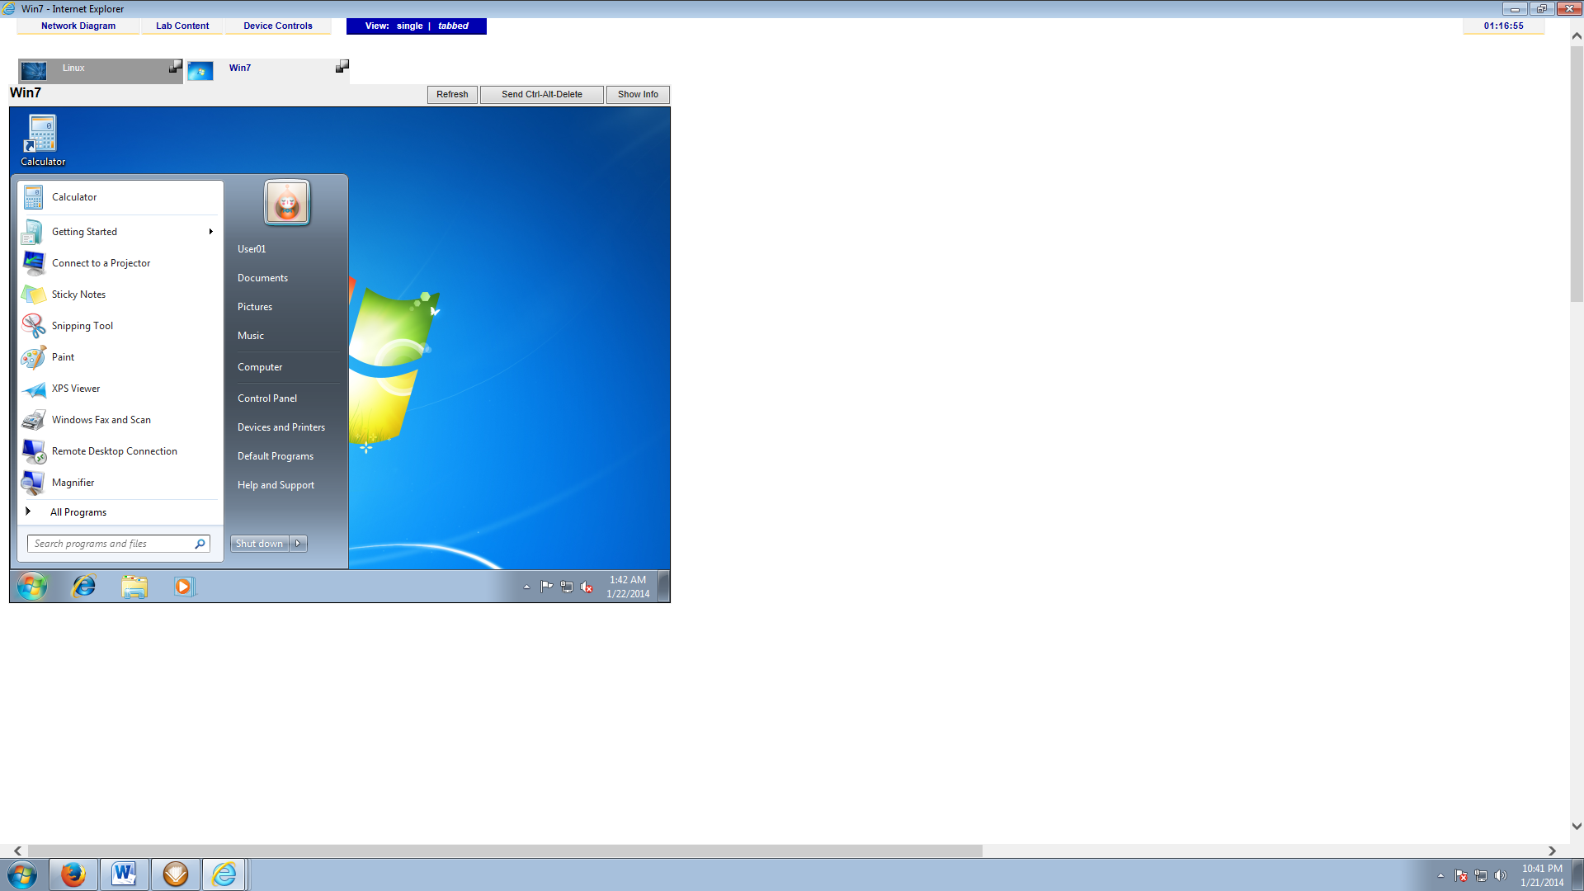
2. Activity 3-3, after #8 (6 points)

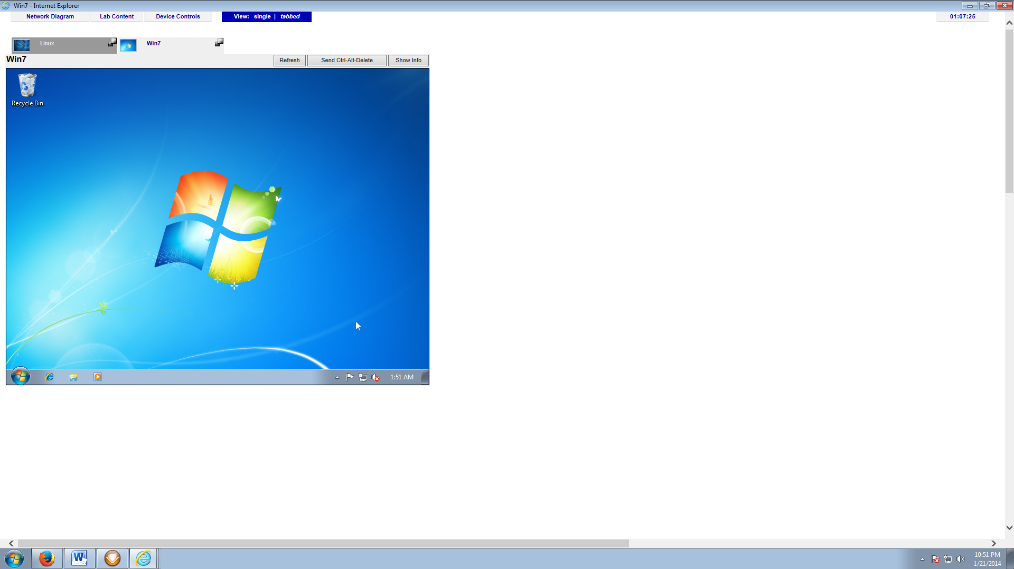

1. Activity 3-4 after #5 (6 points)

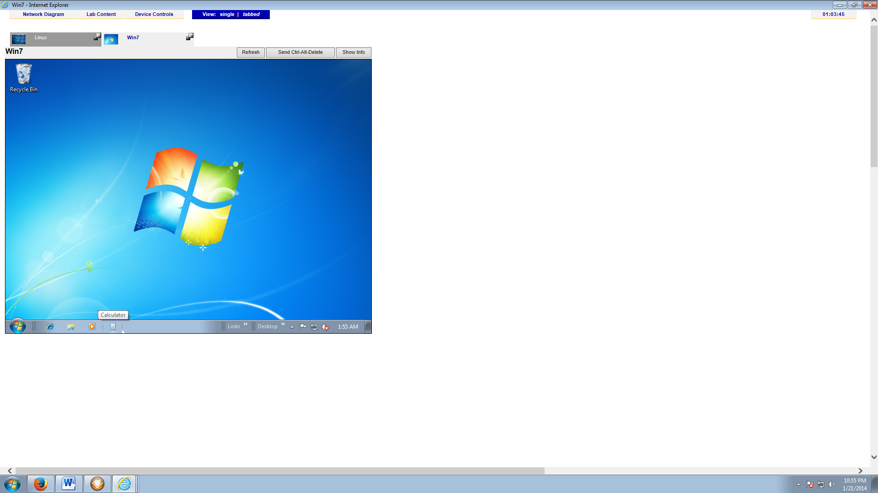

1. Activity 3-5, after #4. Note the terminal icon on the panel. (6 points)

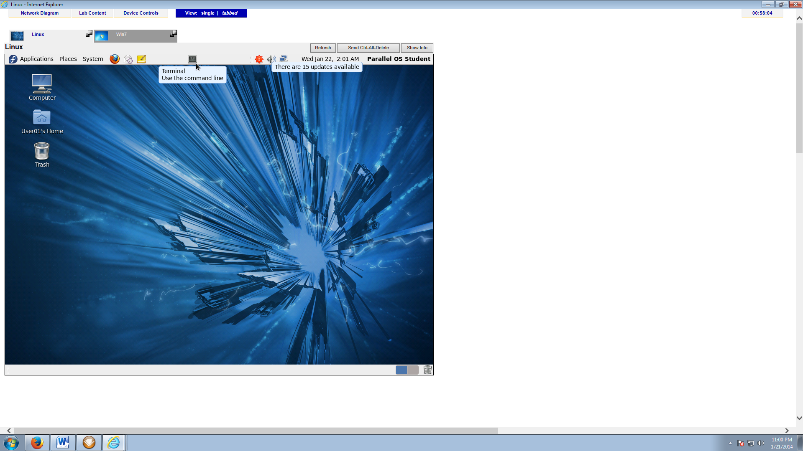

1. Activity 3-9 after #6 (any background) (6 points)

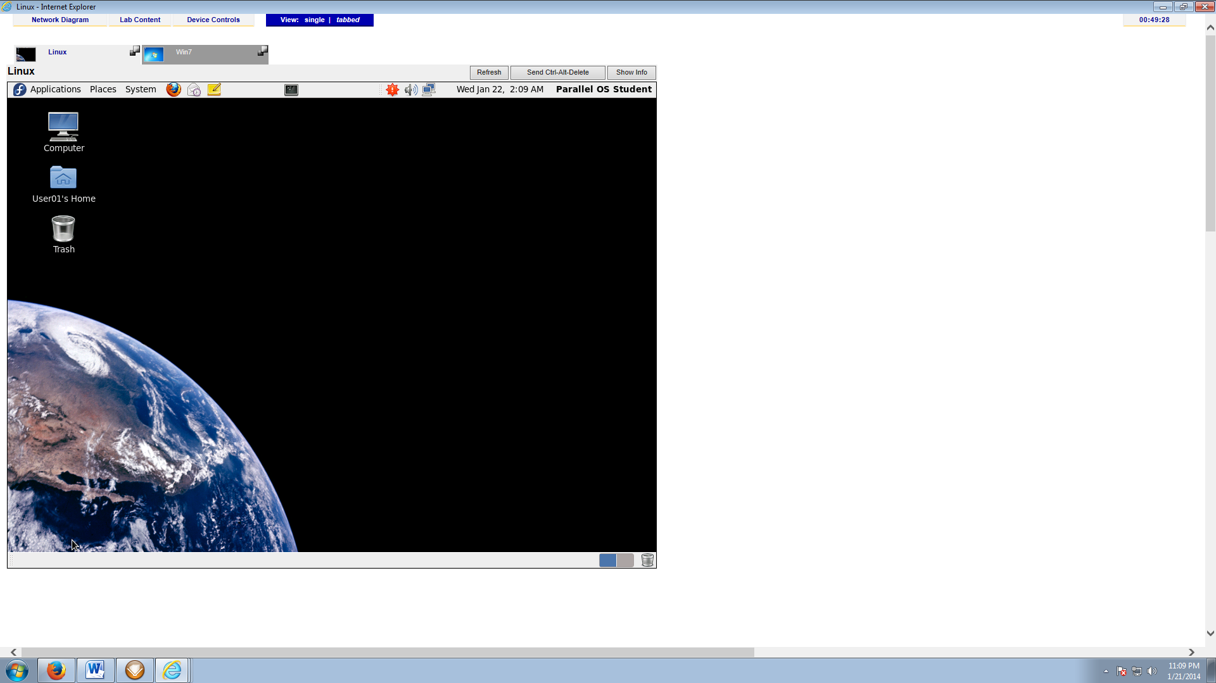

1. Activity 3-15 after #4 (6 points)  
   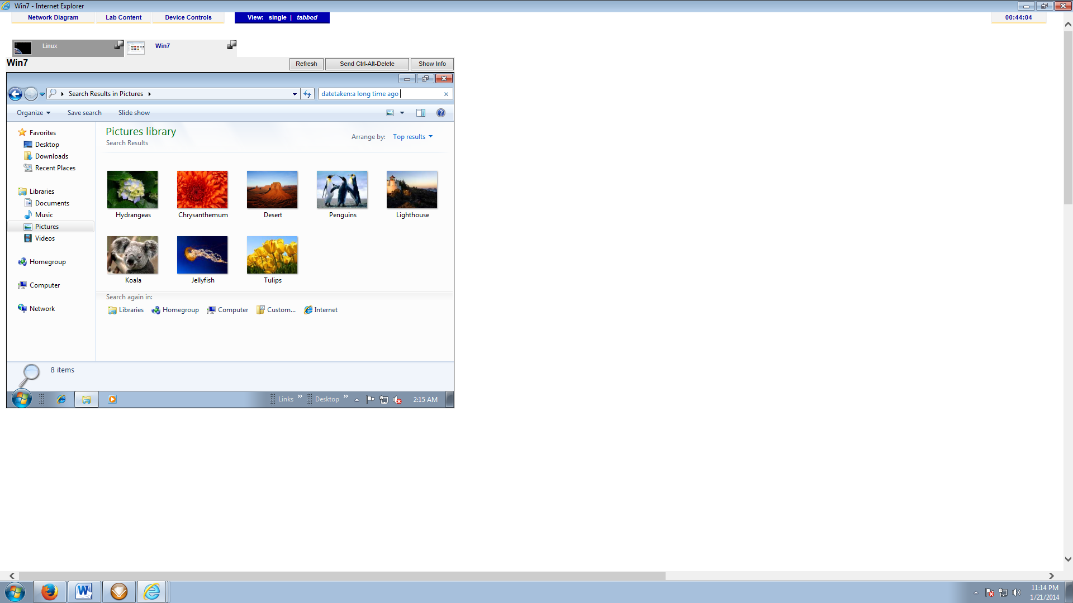
2. Activity 3-16 after #6 – show the list view (7 points)  
   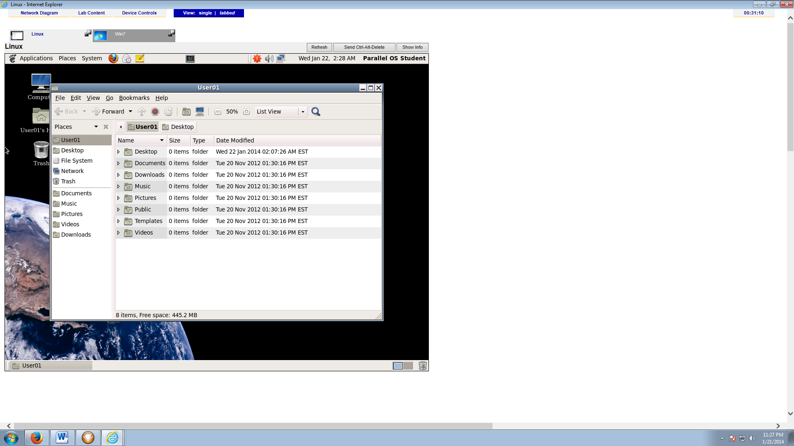
3. Activity 3-18 after #7 (7 points)

